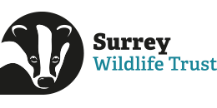
Surrey Wildlife Trust Work Experience Application Form
Thank you for your interest in joining Surrey Wildlife Trust’s work experience programme. To apply, please complete our application form and email it to Volunteers and Communities Officer, Sam, at volunteers@surreywt.org.uk
Please submit your application by Monday 31st March. We will be in touch shortly after to let you know if we are able to offer you a place. Please note, spaces are limited, so we are unfortunately unable to guarantee a space for everyone who applies.

Which date(s) are you available for work experience:
- Monday 30th June – Friday 4th July yes / no (please delete as appropriate)
- Monday 14th July – Friday 18th July yes / no (please delete as appropriate)

Why would you like to complete work experience with Surrey Wildlife Trust?

Please tell us a bit about yourself and your interests:

What are you hoping to gain from your work experience?

Name:

Year group:

